**DS LAB FILE**

**Name – Tanishq Kashyap**

**Roll no – 24/SCA/BCA(AI&ML)/067**

**Section – IID**

**CODES**

1. **BINARY SEARCH**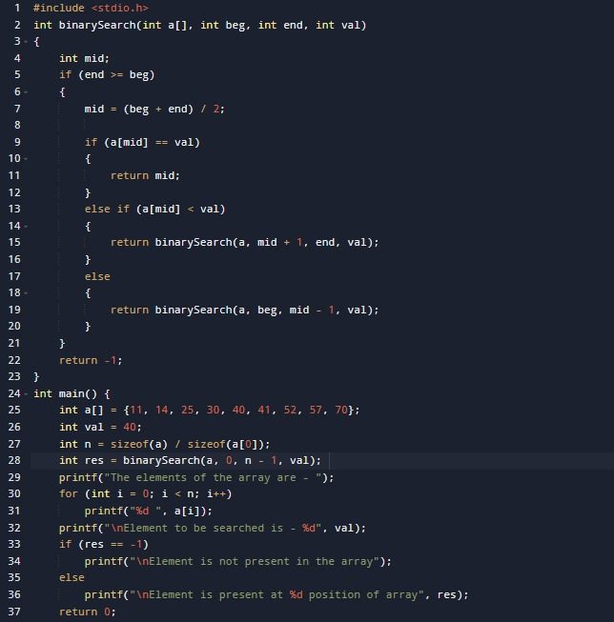

**OUTPUT**

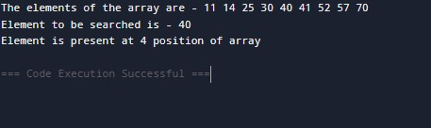

**2.PASSING ARRAY TO FUNCTION**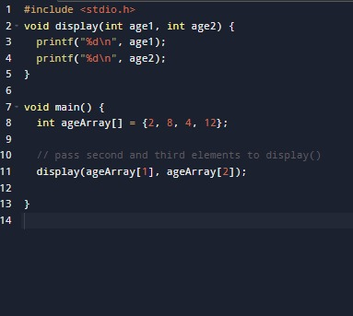

**OUTPUT**

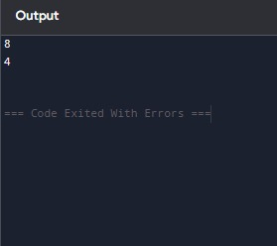

**3.LINEAR SEARCH**

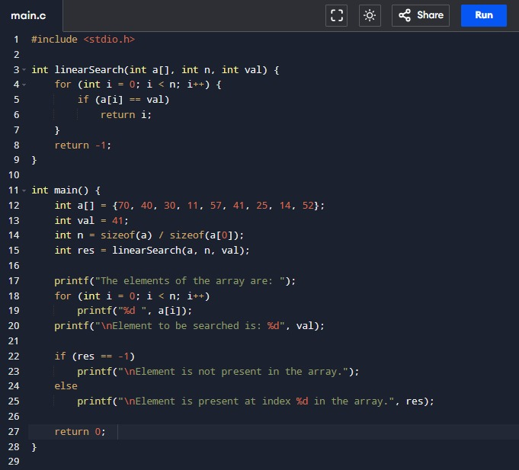

**OUTPUT**

